# Advance Excel Assignment 2

**1. What does the dollar($) sign do?**

**Ans:** The dollar sign in an Excel cell reference affects just one thing - it instructs Excel how to treat the reference when the formula is moved or copied to other cells. In a nutshell, using the $ sign before the row and column coordinates makes an absolute cell reference that won't change.

If we want to only copy the formula but keep the same reference from the previous cell, then $ sign can help.

Whenever you use a $ sign before the cell reference (such as $B$3), you’re telling Excel to keep referring to cell B3 even when you copy and paste the formula.

Ways to add $ in the cell: Add it manually or by pressing F4 key and pointing to the cursor where you wish to change

($) sign can be used in two different ways:

1. Absolute Reference: Use $ sign twice in reference like $B$3- the reference stays constant here,it won't change
2. Mixed References: Use dollar sign only once example $C3 or C$3- its slightly complicated way of referencing and can be used this way:
   1. When you add a dollar sign in front of the column alphabet (C in this example), it locks the column only. This means that if you copy-paste the formula that uses $C3, the column would not change, but the row can change.
   2. when you add a dollar sign in front of the row number (3 in this example), it locks the row only. This means that if you copy-paste the formula that uses C$3, the row would not change, but the column can change.

**2. How to Change the Reference from Relative to Absolute (or Mixed)?**

**Ans.** In Order to Change the Reference from Relative to Absolute or Mixed, we can take help of the dollar($) sign. Dollar($) sign can be added either manually or by using F4 shortcut key. Here’s what each dollar($) sign means in context to cell reference:

1. $A$2: means the cell will always refer to column A and row 2 in the formula- **absolute reference.** We get this by pressing F4 one time, A2 will change to $A$2
2. A$2: Means the Row 2 will remain fixed but the column can change when the formula is copied. It is a mixed reference. Press F4 two times – A2 will change to A$2
3. $A2: Means Column A is fixed but the row might change,when the formula is copied. It is a mixed reference. Press F4 three times – A2 will change to $A2

**3. Explain the order of operations in excel?**

**Ans:** Operational order dictates the precedence of order of which the calculations occur. They follow the acronym PEMDAS(Parentheses, Exponents, Multiplication, Division,Addition,Subtraction)

1. First, expressions within the parentheses are evaluated.
2. Next, references are resolved. This evaluates single references as well as range references like A1:A5, Other range operations like union and intersection are also operated
3. Then, excel performs exponentiation, then negation , then percent conversions.
4. Followed by multiplication & division, and addition and subtraction
5. Finally concatenation and logical operators are evaluated

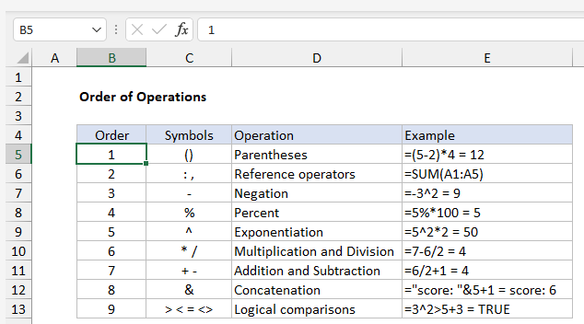

**4. What, according to you, are the top 5 functions in excel and write a basic syntax for any of two?**

**Ans. 5 Important Excel Functions that is absolutely important:**

1. **SUM Function:** This function helps in adding group of numbers in a specific cet of cells.

Eg: =SUM(A2:A5)

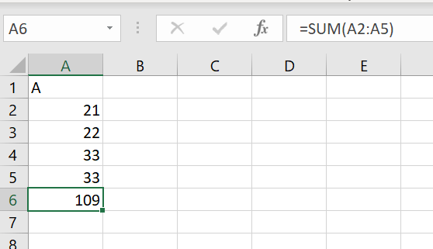

**2.TEXT FUNCTION:** The text function that helps convert a date or number to text based string in a particular format.

In the below example, we use a text formula to find abbreviated day for the date=”Text(D2,”ddd”)

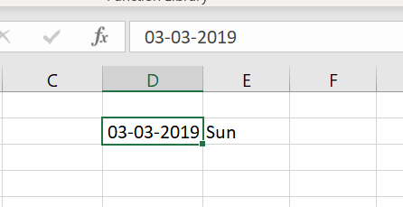

3. VLOOKUP FUNCTION: Vlookup function is often used to search for names, numbers or some data on your sheet. This comes very handy when you have a large volume of data and scrolling through data may become time consuming. The VLookup formula is “=VLOOKUP” (lookup_value, table_array, col_index_num, *range_lookup*).

* “lookup_value” is the data that you wish to find.
* “table_array” is the column where you want to limit your search to.
* “col_index_num” is the column no in the table that you want to return a value from.
* “range_lookup” is an optional argument that allows you to search for the exact match of your lookup value without sorting the table.

**4.AVERAGE FUNCTION:** Average function is useful for getting the average value in the range of cells. It is frequently used for computing and analyzing data on the spreadsheet. It is also known as the arithmetic mean of the data. The syntax formula for the average function is “AVERAGE” (number1, number2, etc.).

Example:“=AVERAGE (A2:A10)” – computes the average of numbers in cells A2 through A10.

5. **CONCATENATE FUNCTION:** This function combines the contents of the combined cell. It is denoted by =CONCAT(TEXT1, TEXT2)

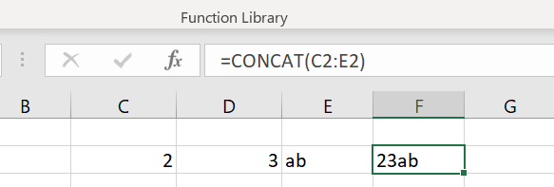

**5. When would you use the subtotal function?**

**Ans:** We use the SUBTOTAL function in Excel instead of SUM,COUNT,MAX to ignore rows hidden by a filter or to ignore rows hidden manually.

When we type “=SUBTOTAL(“ , the AUTOCOMPLETE feature helps in finding the right argument to a particular function. Unlike other functions, like sum, avg, SUBTOTAL doesn’t include the values that are hidden or hidden due to added filters.

The syntax goes like: =SUBTOTAL(function_num,ref1,ref2..): =SUBTOTAL(4,H10:H13)

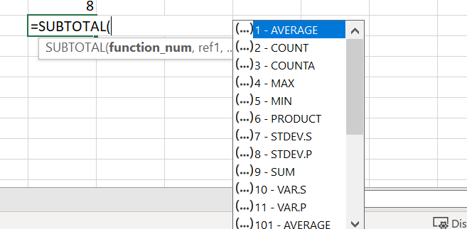

**6. What is the syntax of the vlookup function? Explain the terms in it?**

**Ans:** VLOOKUP function says: =VLOOKUP(What you want to look up, where you want to look for it, the column number in the range containing the value to return, return an Approximate or Exact match – indicated as 1/TRUE, or 0/FALSE).

Syntax: VLOOKUP (value, table, col_index, [range_lookup])

The VLookup formula is “=VLOOKUP” (lookup_value, table_array, col_index_num, *range_lookup*).

* “lookup_value” is the data that you wish to find.
* “table_array” is the column where you want to limit your search to.
* “col_index_num” is the column no in the table that you want to return a value from.
* “range_lookup” is an optional argument that allows you to search for the exact match of your lookup value without sorting the table.